SOP for UBUNTU domain joining process

Step 1:
Open terminal Ctrl + Alt+ t

sudo gedit /etc/hosts/

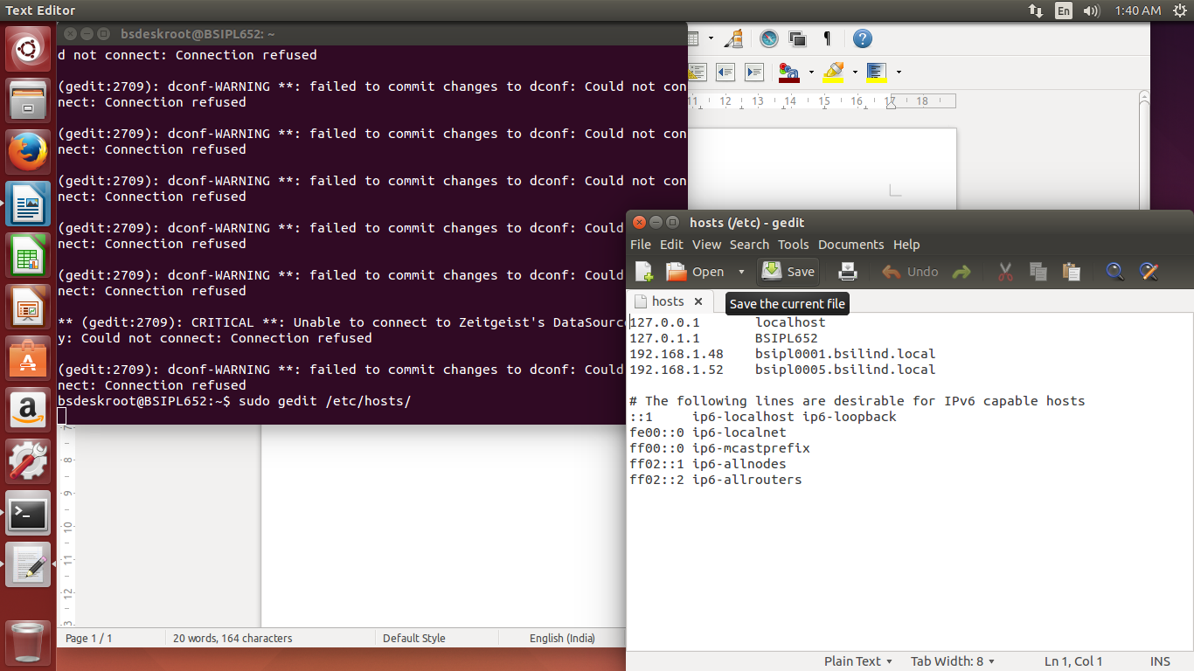
192.168.1.48 bsipl0001.bsilind.local
192.168.1.52 bsipl0005.bsilind.local

Step 2: sudo nano /etc/nsswitch.conf

#hosts: files mdns4_minimal [NOTFOUND=return] dns

hosts: files dns mdns4

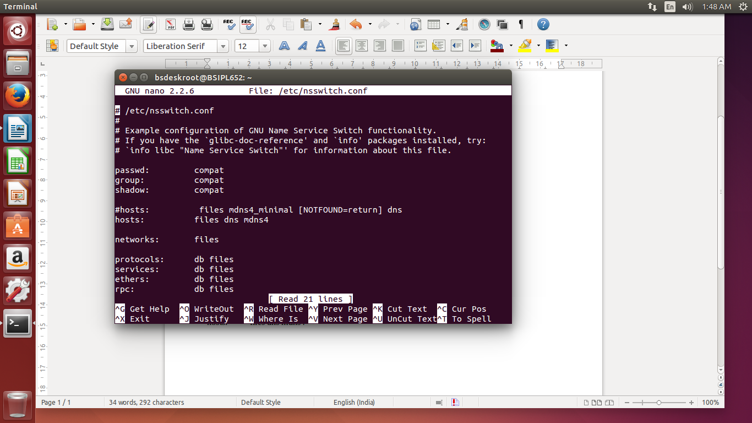

step3 : Update Ubuntu
sudo apt update
sudo apt dist-upgrade
step 4:: Edit avahi config
If you don’t do this you will get conflicts later when installing PBIS.
sudo nano /etc/avahi/avahi-daemon.conf
replace: #domain-name=local
with: domain-name=.alocal
step 5:: Install ssh:
sudo apt install ssh

Step 6: Install PBIS pbis-open-8.5.0.153.linux.x86_64.deb.sh

sudo chmod +x pbis-open-8.5.0.153.linux.x86_64.deb.sh

sudo ./pbis-open-8.5.0.153.linux.x86_64.deb.sh

step7 :: Restart avahi service
sudo service avahi-daemon restart

step 8: Join PC to domain
sudo domainjoin-cli join --disable ssh bsilind.local bsilsrvid
So for our example it would be:
sudo domainjoin-cli join techtalk.local administrator
You will be prompted for the Domain Administrator password and then should see “SUCCESS”.
Step 9: Restart the system

Step 10: Set up the default configuration for domain users

a) Login as root by typing sudo -s
b) from the terminal type the below command

/opt/pbis/bin/config UserDomainPrefix bsilind
/opt/pbis/bin/config AssumeDefaultDomain true
/opt/pbis/bin/config LoginShellTemplate /bin/bash
/opt/pbis/bin/update-dns

Step 11: Give sudo access to users/groups
sudo gedit /etc/sudoers

# User privilege specification

root ALL=(ALL:ALL) ALL

# Members of the admin group may gain root privileges

%admin ALL=(ALL) ALL

%bsilind\\domain^Users ALL=(ALL:ALL) ALL

Restart the system the check the domain user to Login

Note :::If the user not not having sudo privilege, follow the below steps

sudo gedit /etc/sudoers

#User privilege specification
root ALL=(ALL:ALL) ALL
e.g: support@bsilind.local ALL=(ALL:ALL) ALL
e.g: itrequest@bsilind.local ALL=(ALL:ALL) ALL

Step 12::
Edit lightdm (login screen settings)
sudo nano /usr/share/lightdm/lightdm.conf.d/50-unity-greeter.conf
- Insert the following >
allow-guest=false
greeter-show-manual-login=true
… then Reboot

